CONFIRMATION OF THE DATES OF THE PERIOD FOR THE
EXERCISE OF PUBLIC RIGHTS

Name of smaller authority: Balsham Parish Council

County Area (local councils and parish meetings only): SCDC

On behalf of the smaller authority, I confirm that the dates set for the period for the exercise of public rights are as follows:

Commencing on ____Thursday 1st July 2022

and ending on __________Wednesday 11th August 2022 _________________________________

Signed: 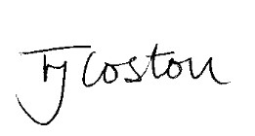

Role: Clerk/RFO

